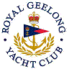 | Royal Geelong Yacht Club Inc.  Est 1859
Trophy Deed of Gift.

Trophy: | Spencer Nall Cup
Presented by: | Spencer Nall
Date: | 1946
For: | Division 1 Maiden Helmsman
Remarks / Revisions | Now Crew’s Race.
Click here for Recipients

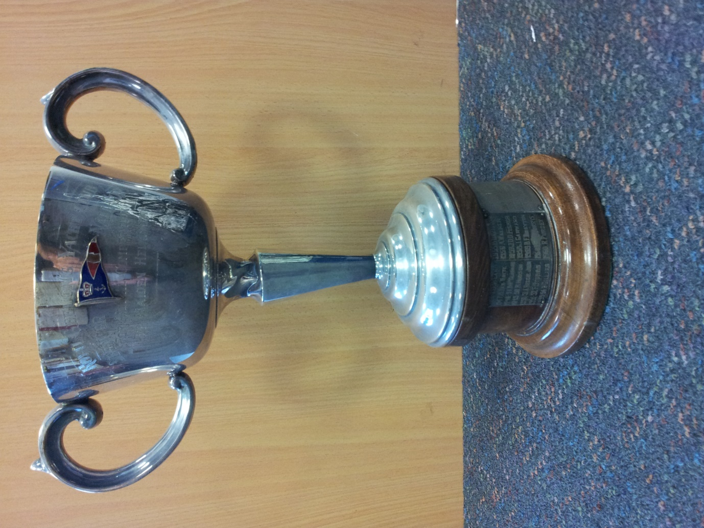

Maiden Helm being defined as someone (male or female) who has not won a race in the Club… ever

